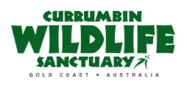
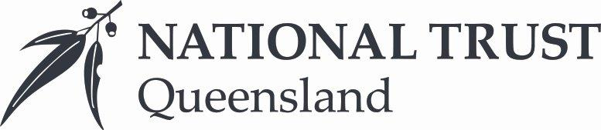

Presentations and Animal Training Officer
- Make a genuine difference working with the dedicated team at the Currumbin Wildlife Sanctuary!
- Voted one of the Gold Coast’s most popular tourist destinations!
- Unique opportunity to be part of a value-led and future focused organisation.
About National Trust Queensland & the Currumbin Wildlife Sanctuary

Voted one of the Gold Coast’s most popular tourist destinations, Currumbin Wildlife Sanctuary (CWS) is the crown jewel of the National Trust of Australia (Queensland) [NTAQ] properties. As one of Queensland’s earliest nature-based tourist destinations, the Sanctuary is a physical embodiment of everything the NTAQ represents: to conserve and advance our natural and cultural heritage for future generations.

As we continue to focus on delivering vibrant and engaging guest experiences, as well as maintaining the highest standard of animal welfare and training, we have an opportunity for an engaging, casual Presentations & Animal Training Officers to join our team.
As Currumbin Wildlife Sanctuary is a NFP and is focused on our Mission of Conservation – we are seeking a truly passionate animal welfare advocate who balances this understanding with the guest experience. This is a truly unique and rare opportunity for an industry professional to join a tourism icon – Currumbin Wildlife Sanctuary.
About the Role
As an Animal Trainer and Presenter, you will report to the Presentations & Animal Training Manager. This hands-on role involves managing animal training, welfare, and husbandry while delivering engaging presentations that educate and entertain our guests.
Key responsibilities include:
- Deliver conservation-based presentations and dynamic shows that align with NTAQ’s vision
- Conduct show training, husbandry training, and foundation training for collection animals
- Utilise best practice and Industry Standard conditioning techniques, to maximise animal health and welfare
- Proactive approach and attention to detail and for animal husbandry duties, including diet management, record-keeping, exhibit maintenance and liaising with the veterinary team
- Perform confidently in shows and presentations, adapting to both scripted and unscripted scenarios
- Provide animal-visitor interactions including wildlife photo opportunities
- Collaborate with the Marketing and Events Team for media requests and special events
- Supervise and mentor students and volunteers

About You
To be successful in this role, you will have hands-on experience within the commercial zoo industry, along with knowledge in animal training and public presentations. Additional qualifications and skills include:
- Certificate III in Captive Animal Management or relevant qualifications
- Knowledge of operant conditioning, animal husbandry and best animal welfare practices
- High-level communication skills and the ability to engage diverse audiences
- Experience with training a variety of animals and free flight birds is an advantage
- Knowledge and understanding of ZAA standards and practises.
- A reliable, flexible, and positive attitude, with a high standard of personal presentation
- Ability to work cohesively in a team or independently
- Flexible availability across weekdays, weekends and holidays.
- Manual driver’s license required
What we can offer
Just as our charter is to protect, conserve, and celebrate the Environmental, Built and Cultural heritage of our State – we also are committed to ensuring our Team Members are protected, taken care of and of course celebrated! We offer current and future team members:
- Flexible Work Practices
- Tertiary Education Partners for access to recognized Qualifications
- NTAQ Team Member Card offering unlimited entry to Currumbin Wildlife Sanctuary and other SEQ sites and generous retail & food & beverage discounts
- Currumbin Wildlife Sanctuary Family & Friends Passes
- Access to 470+ fitness facilities through Fitness Passport for you and your family

