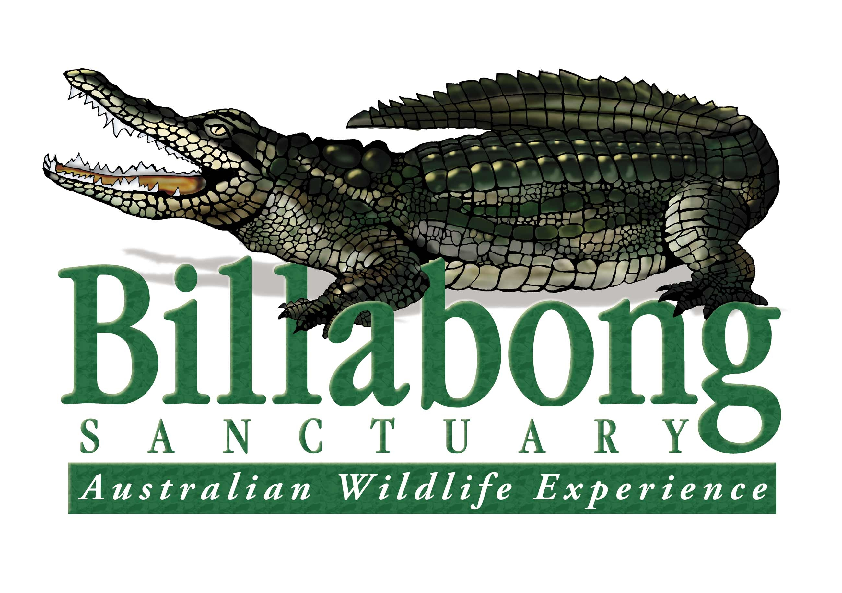

**🌿 Join Our Wildlife Team – Ranger (General Duties)**  
📍 **Billabong Sanctuary, Townsville**  
📅 **Permanent Position | Immediate Start**

Are you passionate about Australian wildlife and ready to take the next step in your animal care career? Billabong Sanctuary, a privately owned wildlife park with 40 years of experience, is looking for a dedicated and experienced **Full time General** **Ranger (General Duties)** to join our small and committed team.

**About Us:**

Billabong Sanctuary is a leader in wildlife education and interaction, proudly holding Advanced Accreditation with the Eco Tourism Association and participating in captive breeding programs for several endangered species. We offer a supportive, family-like workplace culture that values innovation, high performance, and teamwork.

**About the Role:**

This is an exciting opportunity for an animal care professional with a strong background in native species. Working closely with the Heads of our Reptile, Bird, and Mammal Departments, your primary responsibilities will include:

* Daily care and husbandry of a variety of native animals
* Cleaning and maintaining enclosures
* Food preparation and health checks
* Delivering wildlife presentations (birds, reptiles, mammals)
* Leading educational talks and engaging with school groups, tours, and special events

**What We’re Looking For:**

To be successful in this role, you’ll need:

* Several years of proven experience working with Australian native fauna (experience with large reptiles highly regarded)
* Strong communication and interpretive presentation skills
* Strict attention to safety, protocols, and animal welfare
* Availability to work across a 7-day roster including weekends, public and school holidays
* High level of physical fitness and a strong work ethic
* Manual driver’s licence and own transport
* Current First Aid Certificate, Blue Card, and Q Fever vaccination
* Enthusiasm, professionalism, and a mature, team-oriented attitude
* Please detail any additional relevant wildlife experience in your application

**What We Offer:**

* Hands-on experience with a wide range of native Australian wildlife
* Supportive, close-knit team culture
* Weekly team meetings and ongoing training opportunities
* Annual free First Aid refresher course
* Potential for crocodile handling training under our Code of Practice (for suitable candidates)
* A strong focus on safety, welfare, and Zero Harm principles

**How to Apply:**

Please send your **cover letter** (addressing the above criteria) and **resume** to:

📧 **gm@billabongsanctuary.com.au**  
🗓 **Applications close: 3rd June, 2025**

Join us and help deliver the best interactive wildlife experience in Australia!