BILLABONG SANCTUARY

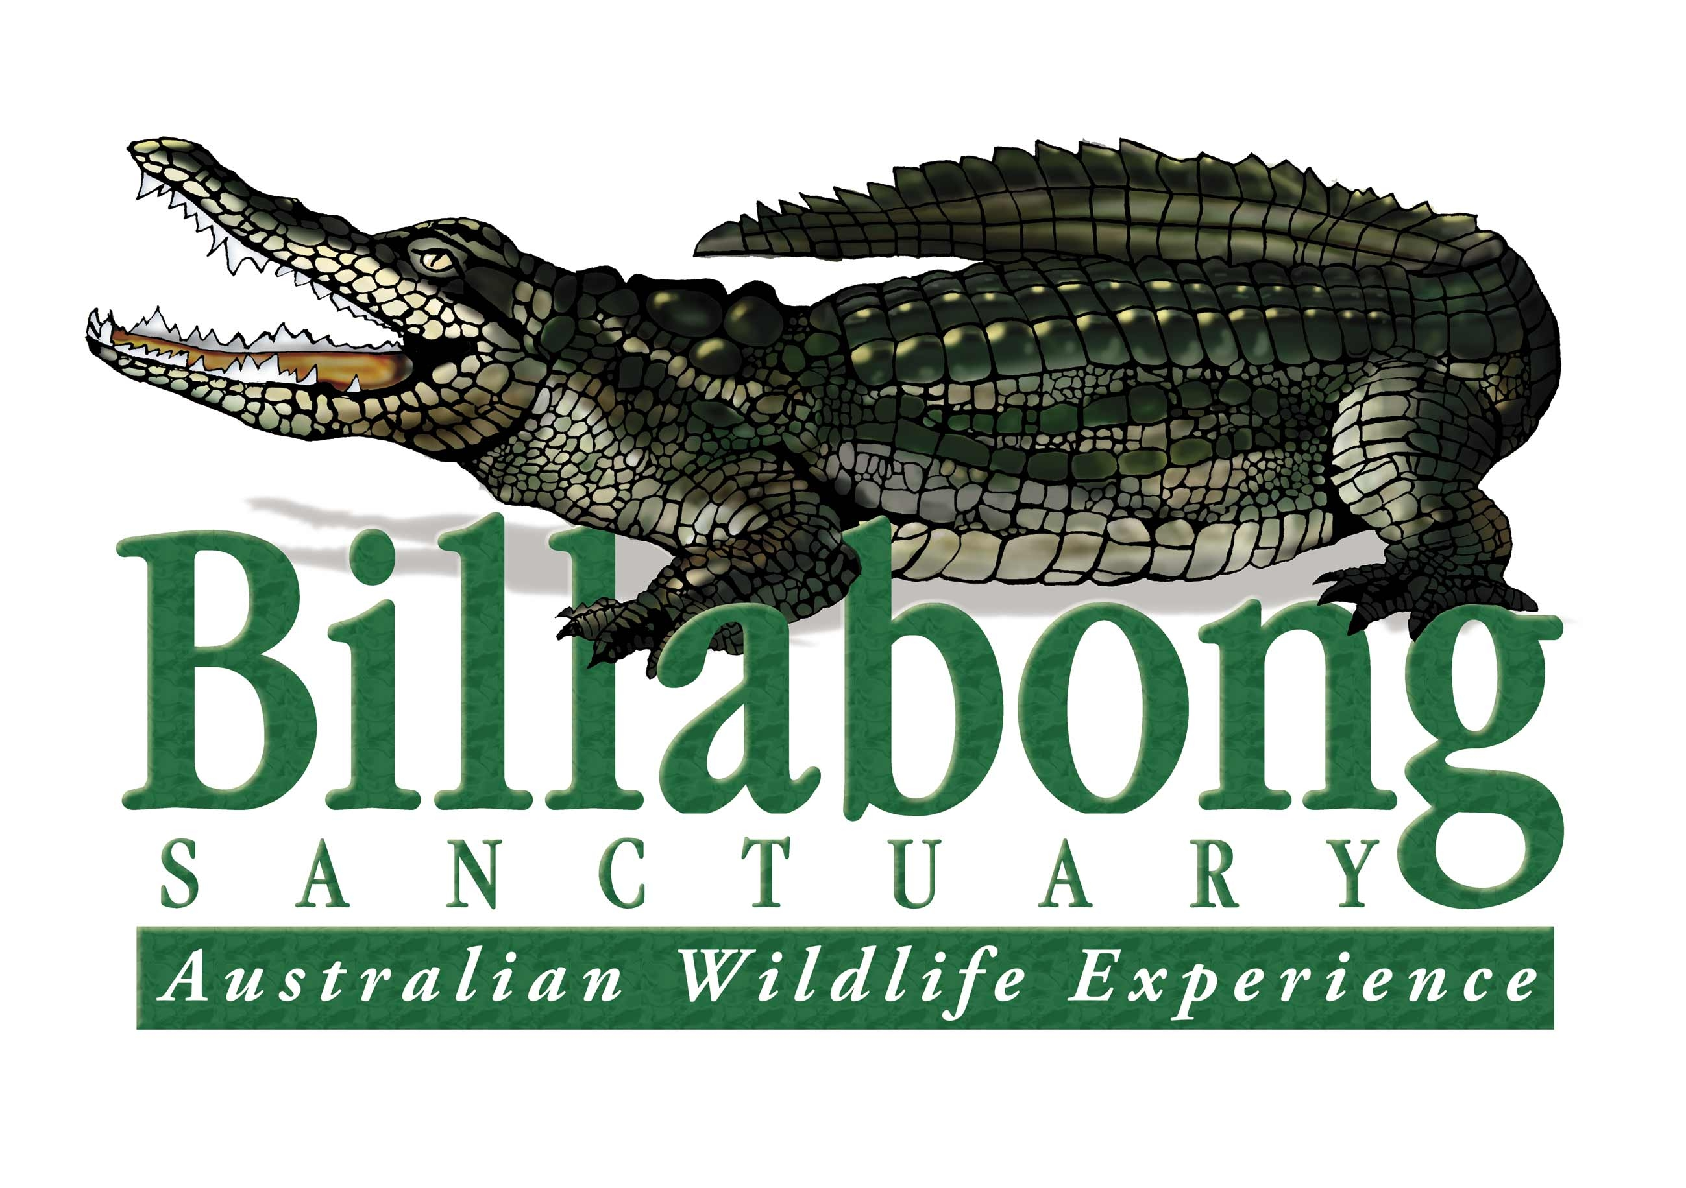

TOWNSVILLE

Permanent position for Team Leader/Ranger for the Bird Department

**Billabong Sanctuary**

Billabong Sanctuary is a privately owned and managed wildlife park being established and operated by the present owners for 39 years.

Billabong Sanctuary is customer focused, delivering the best interactive wildlife experience in Australia. The Sanctuary has Advanced Accreditation with the Eco Tourism Association, is an Accredited member of the Zoo and aquarium association of Australia and is involved with many of their captive breeding programmes for endangered species.

We pride ourselves on our family culture where you are valued, supported and empowered to contribute, and where high performance and innovation is encouraged.

**About the role**

Billabong Sanctuary has an exciting opportunity to join our small and dedicated team.

The ideal candidate will have documented and proven experience with:

* Environmental and behavioural requirements of birds
* Understanding of the five domains of animal welfare
* Management of visitor experiences
* Australian bird reproduction requirements, mating opportunities and health checks on all bird species within our department

**Primary duties.**

* Liaising with Curator and the management team, you will be required to meet “Key performance criteria and indicators”.
* Liaison with the curator on future bird species that could be introduced at Billabong.
* Be team focused and can effectively time manage alongside your daily responsibilities.
* As a team leader, you will be responsible for working alongside and training other keepers with the Sanctuary’s collection of birds.
* Ensuring compliance with our high standard of daily husbandry, integrity and or maintenance of enclosures, conducting animal health checks.
* Assist with training programs and procedures for our bird collection.
* Presentation of daily free-flight bird show
* Shared fauna presentations of mammals, birds and reptiles with other keepers.
* Lessons to school groups, coach tours and cruise ships.

**To succeed in this role, you will need:**

* Certificate iii in Captive Animals, tertiary qualifications or equivalent experience.
* Three years’ experience in a supervisory role with captive birds.
* Experience with conditioning for presentations, including parrots and raptors.
* Be fit for physical work in a North Qld environment, enthusiastic, mature-minded, confident, well presented and able to demonstrate a high level of work ethic and initiative.
* The utmost regard to safety and strict adherence to procedures and policies.
* Excellent public speaking and visitor services skills.
* Computer skills with record keeping on Species 360.
* 7 day a week availability including weekends, public holidays and school holidays.
* Hold a manual driver’s license and own transport.
* Current first aid certificate, hold a Queensland blue card (or ability to obtain) and vaccination against zoonotic diseases – hep A, hep B (preferred) and Q fever (mandatory).

**What we offer:**

* Billabong Sanctuary recognises the importance of diversity with the opportunity to experience working with a wide range of Australian native fauna.
* A workplace that promotes our core brand values to our customers, employees and fauna.
* Work/life balance
* A workplace that believes Zero Harm is achievable and continuously strives to achieve this goal.
* Weekly team meetings.
* A small team environment working together to provide the best care to our animals.

**To apply**

Email your resume, cover letter outlining how you meet all the above criteria and a 5-minute video presentation on an Australian native bird species.

Email to the General Manager:

[gm@billabongsanctuary.com.au](mailto:gm@billabongsanctuary.com.au)

Applications close 31st January 2025