BILLABONG SANCTUARY

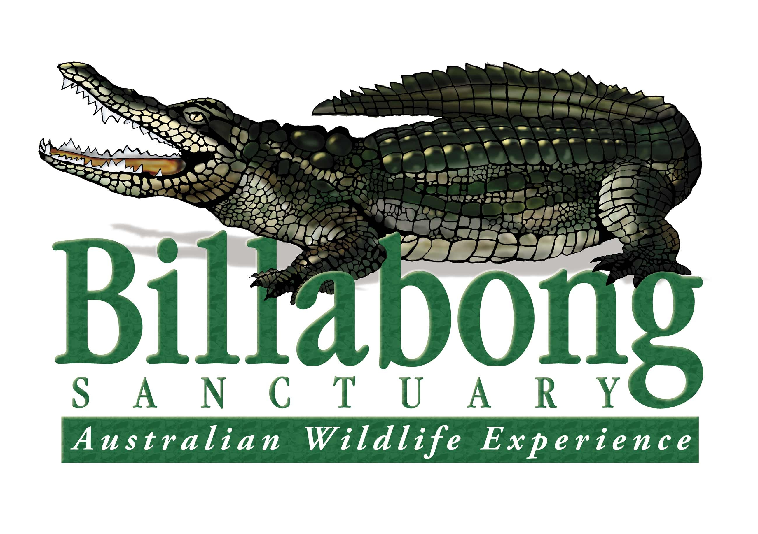

TOWNSVILLE

We have an exciting opportunity to join the team here a Billabong sanctuary, as we are seeking an outgoing enthusiastic person for a permanent position with an immediate start, as the;

Full time reptile and crocodile Zookeeper.

**About Billabong Sanctuary**

Billabong Sanctuary is a privately owned and managed wildlife park being established and operated by the present owners for 39 years.

Billabong Sanctuary is customer focused, delivering the best interactive wildlife experience in Australia. The Sanctuary has Advanced Accreditation with the Eco Tourism Association and is involved in captive breeding programmes for several endangered species.

We pride ourselves on our family culture where you are valued, supported and empowered to contribute, and where high performance and innovation is encouraged.

**About the role**

Billabong Sanctuary has an exciting opportunity to join our small and dedicated team of rangers and become one of our Full time reptile and crocodile zookeeper.

The ideal candidate will have documented and proven experience with in-enclosure feeding of Estuarine crocodiles 3 metres or greater.

An applicant with extensive experience with crocodiles less than 3 metres will be considered. If you have excelled in basic reptile keeping and are looking to further your experience, you will be required to work with and handle various reptiles species including 3.5 metres 25kg Burmese python, Mulga snake or a 5.2 metre estuarine crocodile, then this role may be for you.

Previous experience with other native species is considered desirable to this position.

Experience working with venomous snakes would be very advantageous.

Primary duties;

* Assist with the daily operations of our Reptile Department, with a high standard in the care and welfare of the Sanctuary’s collection of reptiles such as cleaning and maintenance of enclosures, maintaining feeding requirements and conducting animal health checks.
* Work with our Senior ranger and wildlife curator to ensure Department of environment & science records are maintained accurately.
* Data entry of reptile records into Species360.
* Assist with the senor ranger on training new staff to work with crocodiles and venomous snakes
* Shared fauna presentations of mammals, birds and reptiles with other staff
* Lessons to school groups, tours with coach groups, cruise ships or birthday parties.
* Crocodile and venomous snake awareness demonstrations to private businesses.

**To succeed in this role, you will need:**

* The utmost regard to safety and strict adherence to procedures and policies.
* Strong communication skills with your interpretative presentations.
* 7 day a week availability including weekends, public holidays and school holidays.
* Applicant must be fit for physical work, enthusiastic, mature-minded, confident, well presented and able to demonstrate a high level of work ethic and initiative.
* Manual drivers’ licence - own transport essential.
* Current first aid certificate, blue card and Q fever vaccination essential.
* Documented evidence of previous crocodile experience with an emphasis on your **“In enclosure”** performance.
* Detail any other wildlife experience.

**What we offer:**

* Billabong Sanctuary recognises the importance of diversity, with the opportunity to experience working with a wide range of Australian native fauna and exotic wildlife such as Burmese Pythons or American Alligators
* A workplace that promotes our core brand values to our customers, employees and fauna.
* A workplace that believes Zero Harm is achievable and continuously strives to achieve this goal.
* A small team environment working together to provide the best practice welfare and care to our animals.
* Graduated training through our code of practice for working with crocodiles.
* A chance to work with a crocodile over 5metres long

**To apply**

If you think you would like to join our team and feel you meet the criteria for this position. In your application, please provide a cover letter outlining how you meet all of the above criteria and your suitability for the role through your experience of working with crocodiles. Also include your resume.

Email to the curator:

[gm@billabongsanctuary.com.au](mailto:gm@billabongsanctuary.com.au)

Applications close 31st January 2025