ZWVNA – a new sub-committee of the ASZK
A new sub-committee of the ASZK Zoo and Wildlife Veterinary Nurses Australasia (ZWVNA) is the creation of a core group of committed Zoo and Wildlife Veterinary Nurses who have been driving the idea of becoming formally recognised over the course of several years, finally making the dream a reality.
As a formal committee we hope to provide a platform for Zoo and Wildlife Nurses across Australasia to meet and learn through formal conferences, informal networking and questioning (via our email forum) and to advocate for the diverse array of patients we encounter by striving for best practice via these means of educating ourselves to do better.
We would like to introduce ourselves with our individual biographies (and of course a happy snap!)

Name: Debbie Pritchard
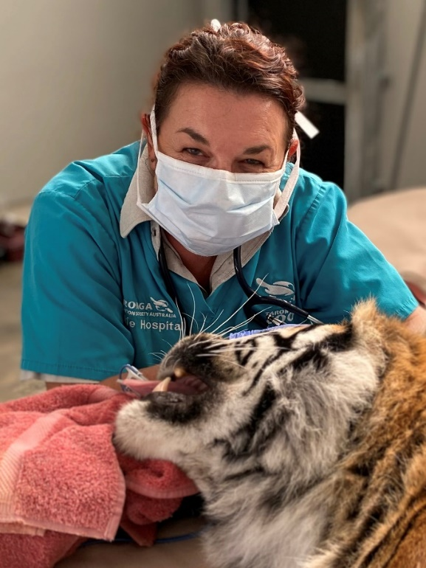
Position: Senior Zoo Veterinary Nurse and Keeper, Taronga Wildlife Hospital Sydney
Qualifications: Cert IV Veterinary Nursing, Cert IV Training and Assessment, Conservation and Biodiversity (Syd Uni short course), Cert III Horsemanship, Cert IV Captive Animals.
ZWVNA: ZWVNA committee Secretary and NSW representative
Debbie Pritchard is a registered Veterinary Nurse with a plethora of animal industry qualifications. In 1992 Debbie successfully gained the position of Divisional manager, Taronga Veterinary and Quarantine Center and now 30 + years later maintains a part time position within the hospital as a Senior Zoo Veterinary Nurse/Keeper where she particularly enjoys working with the wildlife patients and the specialist aspects of clinical nursing, hospital husbandry and wildlife rehabilitation.
“I am passionate about this industry and all it represents with its powerful conservation and animal welfare targets. I am proud to have strived for the recognition and understanding of what the Zoo & Wildlife Veterinary Nurses of Australasia have contributed within this field; from zoo population veterinary care and health management to rewilding conservation programs and everything in-between.”

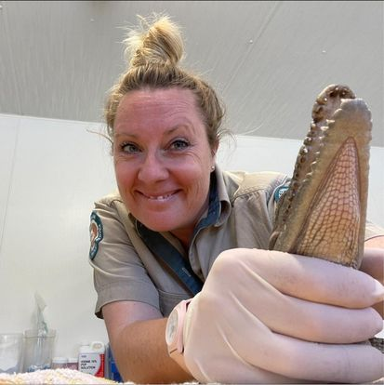
Name: Emma Whitlock
Position: Veterinary Nurse SeaWorld Aus + Dept Environment and Science (Moggill Koala Rehab Centre) + Trainer/Assessor Cert IV Veterinary Nursing Native Wildlife TAFE NSW
Qualifications: National Diploma Animal Care, BSc (Hons) Veterinary Nursing Science, Cert II Veterinary Nurse, Cert III Veterinary Nurse, Registered Veterinary Nurse (all UK), Cert IV Training and Assessment
ZWVNA: ZWVNA committee member and Qld representative
Since qualifying as a vet nurse in 2003 Emma has worked almost exclusively with Zoo, Exotic and Wildlife patients, across a broad range of organisations and facilities. Some of the positions held by Emma include Vet Nurse at the Zoological Society of London, Senior Nurse at (what was then) the UKS only 24hr specialist led Avian and Exotic referral hospital, program leader for the degree in Veterinary Nursing, Lead Nurse at the University of Queenslands’ Vet Teaching Hospital and Hospital Manager at the Currumbin Wildlife Hospital (CWH).
In 2020 Emma left her role at the CWH to teach the Cert IV Vet Nursing of Native Wildlife at TAFE NSW – supported by CWH who take students on clinical placement for the duration of their course (18 months). Alongside this teaching role Emma keeps her skills fresh in casual vet nursing roles at SeaWorld Australia and the Queensland Department of Environment and Science.
Emma is passionate about advocating for patient welfare and best practice and hopes that through presenting and teaching more nurses will feel confident in their ability to effectively manage a diverse array of species to the very best of their resources. Randomly her favourite animals are sea hares, snails and tiny frogs!

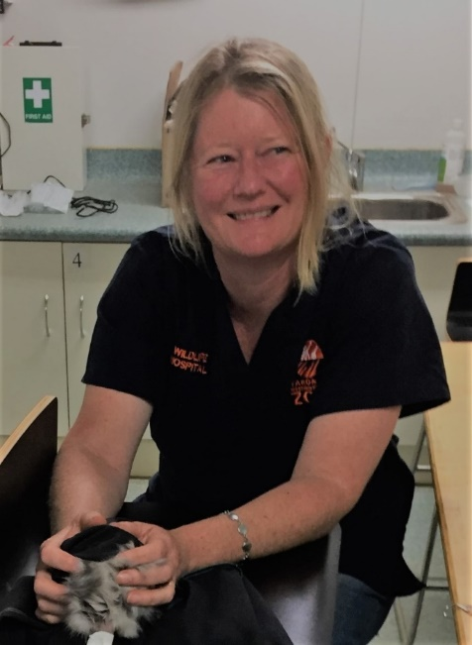
Name: Jodie Lardner-Smith
Position: Senior Veterinary Nurse, Taronga Western Plains Zoo Dubbo
Qualifications: Veterinary Nursing certificate TAFE, Cert IV in Training & Assessment
ZWVNA: ZWVNA committee member and NSW representative
Jodies’ veterinary nursing carer began as a kennel hand in private small animal practice in her young teens. She progressed to full time qualified veterinary nurse in 1989, and in 1991 began working at Taronga Zoo Sydney as a bird keeper. Six months later Jodie transferred to the wildlife hospital in the position of zoo veterinary nurse, where she worked for 3 ½ years before moving to Dubbo to work at Taronga Western Plains Zoo.
Jodie has worked in various roles since arriving in Dubbo but nursing has always been her passion. She has a keen interest in hand raising native and exotic species. ‘I’m very fortunate for the opportunities I have had during my zoo carer working with a diverse variety of wildlife, incredible staff and dedicated wildlife carers. Zoo and wildlife veterinary nursing is a wonderful carer with many challenges and amazing experiences and I fortunate to have been doing for nearly 32 years.’

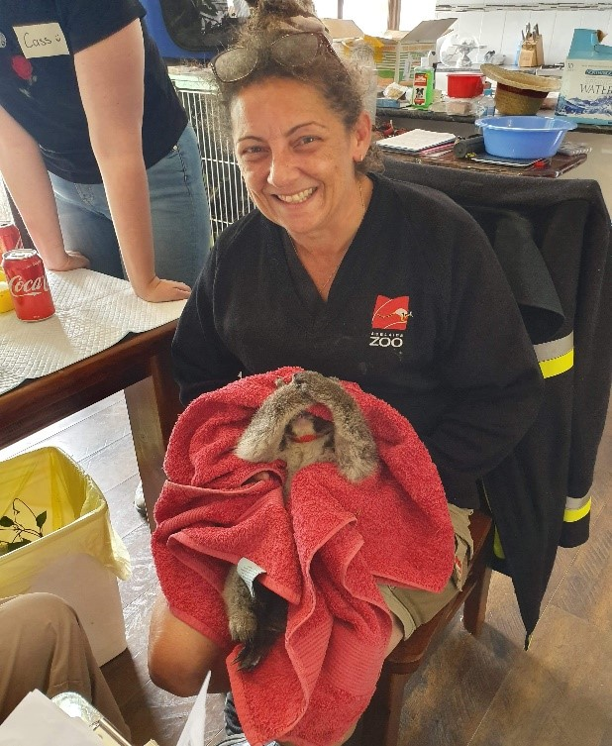
Name: Di Hakof
Position: Hospital Manager and Senior Hand Rearing Advisor Zoos South Australia
Qualifcations: Cert IV in Veterinary Nursing and Cert IV in Captive Animal Management
ZWVNA: ZWVNA committee member and SA representative
Di Hakof has worked for Zoos South Australia for 33 years and manages both Adelaide Zoo and Monarto Safari Park Animal Health Departments
Di loves advocating for the animals and staff under her care and management. She has written and delivered many papers in all areas of wildlife and zoo veterinary nursing, and has a special interest in hand rearing wild animals particularly in the area of Assist Rearing Animals.
She has attended Oil Spills, is heavily involved in bushfire triage and recovery, native animal rescues such as assisting with the local wild Dolphin population health events, sea turtle rescues and any other species requiring assistance.
‘I have never known a time that I have not wanted to do this! It is such a challenging area to work in and this is where I love to troubleshoot and work out the best and most effective way to work with ill and injured wildlife to ensure everything has been done to provide the best outcome for these creatures under our care.’

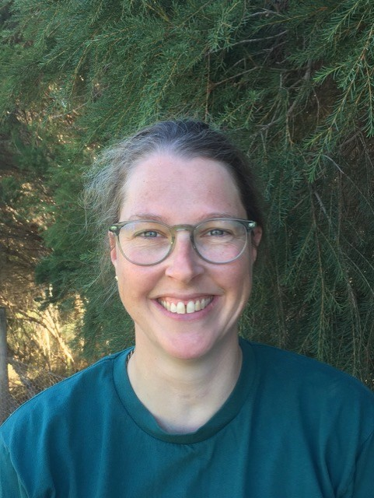
Name: Gerry Ross
Position: Life Sciences Manager, Animal Health at Healesville Sanctuary
Qualifications: Bachelor of Biological Science BSc, Cert IV Veterinary Nursing, Delta institute - Animal behaviour and training - Certificate IV, Advanced diploma of leadership and management
ZWVNA: ZWVNA committee member and Victorian representative
Gerry Ross has been nursing for almost 23 years. She began her career at a bird specialist clinic where she developed a love of working with birds. She moved on to work at a small animal practice, completing her nursing certificate while developing her knowledge and interest in anaesthesia and surgery.
In 2005, Gerry started working for Zoos Victoria as a nurse at Healesville Sanctuary’s Australian Wildlife Health Centre, further growing her passion for wildlife and conservation.
In 2007, she stepped into a senior nursing role and in 2016 Gerry took on the role of hospital manager (non-clinical) overseeing the staff and operations of the wildlife centre.
Currently, Gerry manages a large team with a range of full-time, part-time and casual staff, and is responsible for budgets, forward planning and projects.
Gerry’s role is to ensure staff have the ability to provide the best wildlife welfare and rehabilitation possible, through the provision of skills, equipment and facilities.
Gerry’s favourite animal is the echidna.

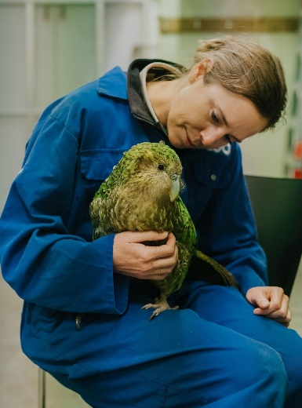
Photo Courtesy of Auckland Zoo
Name: Mikaylie Wilson
Position: Clinical Coordinator, Veterinary Services Auckland Zoo
Qualifications: Cert IV Veterinary Nursing, Cert III Zookeeping
ZWVNA: ZWVNA committee member and NZ representative
Mikaylie started her career in wildlife medicine by volunteering at Taronga Western Plains Zoo while studying veterinary nursing certificate and working full-time in a domestic vet clinic in 1998, for two years.
Starting in 2000, Mikaylie has 23 years wildlife veterinary nursing experience with a range of exotic, Australian and New Zealand native animals across all taxa. Starting work at Taronga Veterinary and Quarantine Centre/Zoo and moving onto Taronga Western Plains Zoo, Vancouver Aquarium, Perth Zoo, and finally Auckland Zoo where she has been the clinical coordinator for the last 10.5 years.
Mikaylie’s passion for pinnipeds saw her working at Vancouver Aquarium, rescuing, and rehabilitating harbor seal pups and then going on to volunteer in Alaska at the Alaskan SeaLife Centre, comparing rehabilitating skills for harbor seals from the two aquariums. This passion has found Mikaylie working on many fieldwork projects including satellite tagging adult male Australian sea lions in WA, adult female NZ sea lions, rescuing leopard seals and capture and restraint of NZ fur seals, NZ sea lion pups and harbor seal pups.
Mikaylie originally moved into wildlife medicine to work with exotic wildlife, however throughout her career, she has seen her passion develop more into field conservation, being able to practically make a difference on the ground with Australian and New Zealand native mammals and birds (all birds but particularly kakapo).
Mikaylie also sits on the WReNNZ (Wildlife Rehabilitators Network of New Zealand) committee and is a wildlife expert for the NOWRT (National Oiled Wildlife Response Team) Auckland region tier 2 and national response tier 3.

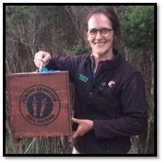
Name: Jenny Kingston, Cert IV VN, RVN
Position: Veterinary Hospital Supervisor, Melbourne Zoo Veterinary Department, Zoos Victoria
Qualifications: Cert IV Veterinary Nursing, RVN, Cert III in Zookeeping, Certificate of Applied Science, Animal Technology
ZWVNA: ZWVNA committee member and Victorian representative
Jenny brings over 35 years of experience in veterinary nursing and zookeeping at Zoos Victoria. In 1988 she joined Melbourne Zoo as a keeper and spent the next 12 years developing her zookeeping skills with native mammals and birds before securing a position in 2000 as a Veterinary Nurse in the Veterinary department. In 2018 Jenny took on the role of Veterinary Hospital Supervisor and currently leads a passionate team of nurses and keepers in a busy hospital setting. The team is dedicated to providing high quality care for the zoos collection alongside the triage, care and rehabilitation of marine and urban wildlife seen through the Marine Response Unit. Throughout her years at ZV, Jenny has also been fortunate enough to work across other roles including her time as a Veterinary Nurse at Werribee Zoo and as Project Officer for the Eastern Barred Bandicoot recovery program. Jenny enjoys all aspects of veterinary nursing and is particularly interested in anaesthesia, hand rearing, conservation fieldwork, wildlife rehabilitation and collaborative efforts with her team to consistently enhance the standards of care in nursing and husbandry practices.

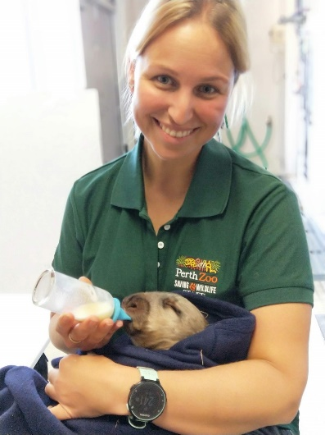
Name: Peta Moore
Position: Veterinary Nursing Supervisor- Perth Zoo
Qualifications: BAppSc (Hons - Wildlife Biology), Master of Health and Wildlife Conservation, Post-graduate Certificate Ornithology, Cert IV VN, Accredited VN
ZWVNA: ZWVNA committee member, WA representative and ASZK committee member (ZWVNA rep)
Peta’s love and passion for wildlife started well before her nursing career, completing a Bachelor of Applied Science in Wildlife Biology with her career aim to always be actively involved in conservation and animal welfare. She completed her Vet Nursing qualification not long after and has been veterinary nursing for 22 years.
Peta started out in a small animal practice that admitted hundreds of wild animals yearly, sparking a passion specifically for nursing our native wildlife. This passion has led to an exciting career veterinary nursing in the zoological and wildlife industry, including working at RSPCA, Australia Zoo Wildlife Hospital, Alice Springs Desert Park and Animals Asia’s Vietnam Bear Rescue Centre.
In 2013 Peta successfully gained a senior veterinary nurse position at Perth Zoo before moving into the supervisor role, which she has now been in for the past 9 years. She is passionate about providing the best possible care to her patients and passing on that knowledge to new generations of zoo and wildlife veterinary nurses and is excited about the collaboration and future opportunities between ASZK and ZWVNA.
Amongst many of Peta’s favourite animals in the wombat ☺.

Name: Kate Simon-Menasse
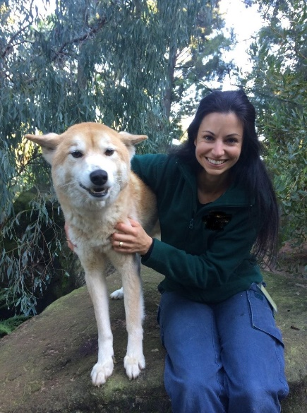
Position: Senior Technical Officer- Veterinary Nurse, Perth Zoo
Qualifications: Cert IV Veterinary Nursing, Accredited Veterinary Nurse, Cert III in Captive Animals, Graduate Cert in Captive Vertebrate Management, Diploma in Veterinary Nursing of Zoo Animals, Diploma in Veterinary Nursing of Avian Species, Diploma of Veterinary Nursing of Reptiles and Amphibians, Cert IV Training and Assessment
ZWVNA: ZWVNA committee member and WA representative
Kate has been nursing at the Perth Zoo for the past 23 years. She becomes more passionate for the job with each passing year and couldn’t imagine doing anything else. She has a special interest in conditioning to facilitate medical procedures, hand raising neonates, Primates and Marine mammals.
Kate's dedication to conservation has seen her travel to many corners of the globe volunteering her skills to assist with projects such as Friends of the Western Ground Parrot, Free the Bears, Zoo Peru, Wildlife Asia and Zoo Peru. Her work with the Black Cockatoo program at Perth Zoo has seen hundreds of birds successfully treated, rehabilitated and released back into the wild significantly impacting the numbers of these endangered birds. Kate won the Veterinary Nurses Council Vet Nurse of the year award in 2019.

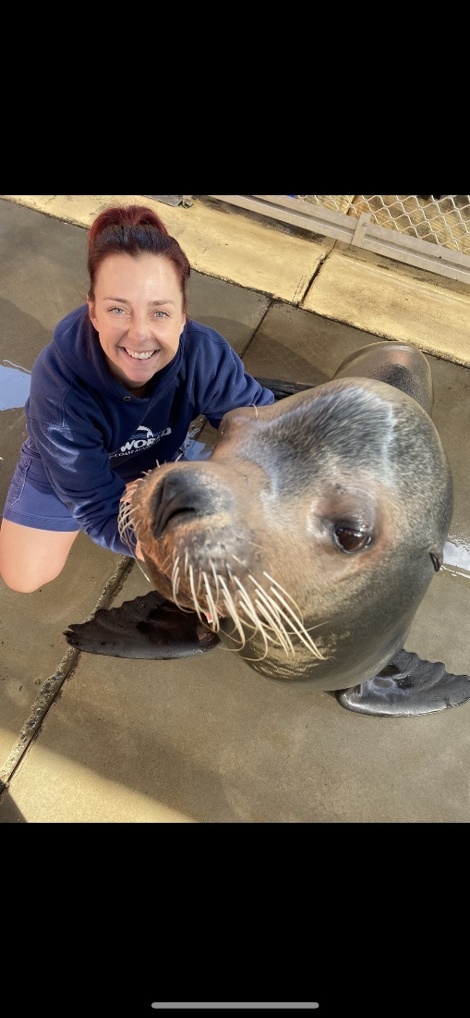
Name: Jenna Mainwaring
Position: Veterinary Nurse and Marine Mammal Trainer, Sea world and Paradise Country (Village Roadshow Theme Parks) + Veterinary Nurse, Queensland Department of Environment and Science’s (Moggill Koala Rehabilitation facility)
Qualifications: Cert IV Veterinary Nursing
ZWVNA: ZWVNA committee member and Qld representative
Jenna has been a veterinary nurse for over 17 years, originally starting in general practice before gaining a position at Sea World as a Marine Mammal Trainer. Not long after her career started at Sea World, she was given the position of Veterinary Nurse for Village Roadshow Theme Parks.
Throughout her career, she has gained extensive experience with many species, marine, native, and exotic. She has experience in marine animal strandings and rehabilitation and has responded to sightings, entanglements and mortalities as a part of the Sea World Rescue Team. She has had the opportunity to travel to other marine facilities in Australia and assist in complex pinniped and cetacean anesthesia and surgical procedures with specialists from all over the world.
Jenna has a passion for threatened species which led her to apply for a casual position with the Moggill Koala Rehabilitation facility. She has recently taken on a casual role at Sea world to complete her Bachelor of Science Degree majoring in wildlife and marine biology. She hopes to bring her veterinary nurse skills into research and field work and one day save a species.

