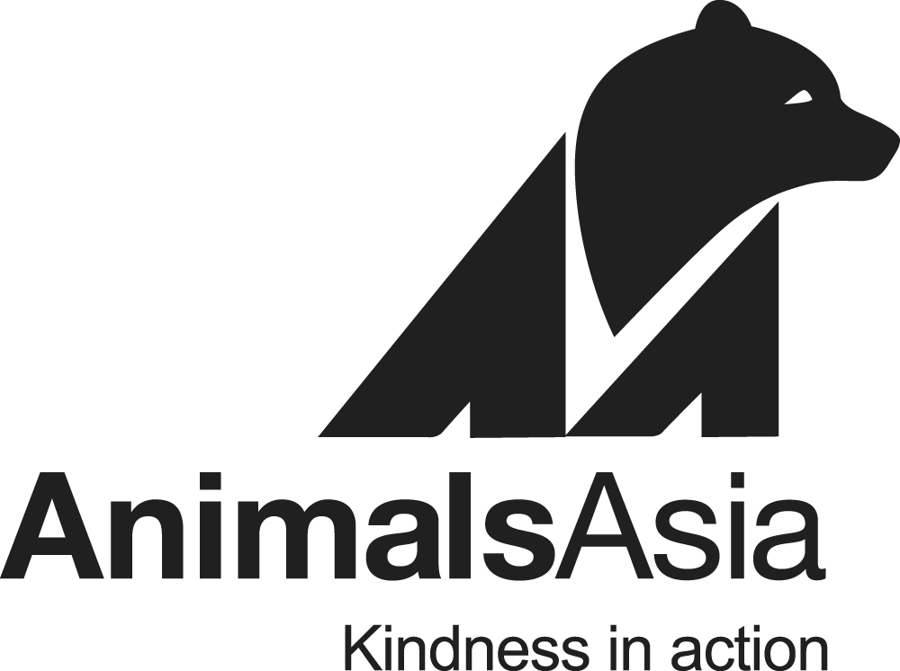

**Bear & Vet Team Director**

Chengdu Bear Rescue Centre, China

**Join the family … be part of the end game**

**About Animals Asia**

Animals Asia is an international animal charity with our headquarters in Hong Kong, with over 400 team members and operations in China, Vietnam, Australia, the United States, the United Kingdom and Europe. The foundation is devoted to protecting moon bears and improving the welfare of animals in Asia. It promotes compassion and respect for all animals and works to bring about long-term change. For more information, please visit [www.animalsasia.org](http://www.animalsasia.org/).

**About the Role**

An exciting opportunity to work in our bear sanctuaries in Chengdu, China.This position reports directly to our Founder & CEO, Jill Robinson. You will be overseeing and managing a team of animal behaviour and veterinary experts along with over 80+ animal care takers at our China Bear Rescue Centre (CBRC).

The Bear and Vet Team Director, China assumes responsibility for all activities, functions, and policies related to the department, including the department’s budget and staff. Working closely with the CEO & Founder, Founding Director and China Director, the position provides strategic direction for the department, consistent with Animals Asia’s overall vision, mission and policies.

\***This is a human management role, and the candidate will not be working as a practicing veterinarian**.

**The ideal candidate:**

* Very strong management skillset and ability to inspire and build capacity within a team.
* Understanding of working abroad and managing a team from diverse backgrounds and cultures.
* Passion for animal welfare.
* Can handle regular out of hours work.
* Can live with colleagues at the sanctuary.

**Why join us?**

* This is an exciting opportunity to work in Chengdu, China and for the internationally renowned organisation, Animals Asia.
* Chance to manage a team of Chinese and expatriate staff to improve the welfare of bears, cats and dogs that reside in the sanctuary.
* Opportunity to rescue and rehabilitate bears.

**Location**: China Bear Rescue Centre (CBRC) in Xindu District, LongQiao, Chengdu, China.

**Job Responsibilities:**

* Oversee and manage the Bear & Vet Team at CBRC and off site, including budget, HR, purchase, evaluations, training and development, and ensure all relevant behavioural enrichment practices, protocols and procedures are functional and strictly adhered to in order to facilitate the care of the bears and other animals both at CBRC and off site.
* Review and refine policies and procedures associated with the sanctuary and care of bears.
* Liaise with the wider management team, such as the Vietnam Bear Rescue Centre, fundraising, communication teams, and construction department, to ensure the smooth running of CBRC.
* Making sure all staff adhere to established Health & Safety policies and procedures, oversee any onsite emergencies and develop and maintain effective working relationships in regard to work procedures, employee relations and procurement related concerns.
* Coordinate bear rescues in conjunction with the China Director, Founding Director & CEO.
* Ensure that inter-department and inter-personal relationships at CBRC are positive, cohesive, and contribute to the overall mission of Animals Asia.

**Job Requirements:**

* Strong people management and leadership skills and the ability to motivate and inspire staff.
* Staff training and development experience.
* Technical expertise in bear behaviour, animal welfare, animal husbandry and/or veterinary medicine.
* At least 5 years working in an animal sanctuary, wildlife rescue centre, wildlife rehabilitation centre, zoological park, or veterinary hospital.
* Bachelor’s degree in biology, zoology, conservation, animal welfare or behaviour, or veterinary science.
* Capable of dealing with and handling emergency situations.
* Good teamwork and communication skills.
* Proficiency in spoken and written English.
* NGO work experience is preferred.
* Suitable candidates must be able to commit for a minimum of 2 years.

Appointment is paid, full-time, five (5) days a week with some weekend work applicable.

**The following items are included in your full-time contract:**

* Basic on-site accommodation: own room and bathroom. Shared communal kitchen and living space.
* Emergency medical insurance & relocation assistance.
* Paid holidays.
* Annual leave.
* Access to Telus, health and wellbeing platform.
* Salary: Commensurate with Experience.

**How to apply:**

Interested parties please forward **PDF copies** of your **cover letter**(stating the applied position) and **CV**to: [hrhkg@animalsasia.org](mailto:hrhkg@animalsasia.org) or click this link https://animalsasia.bamboohr.com/careers/31 to apply.  Only shortlisted candidates will be notified.

For more information on our work, please visit our website at [www.animalsasia.org](http://www.animalsasia.org/)

Personal data collected will be treated in strict confidence and used solely for recruitment purposes.

*Animals Asia values candidates with different backgrounds, experiences, and perspectives. We welcome applicants of every ethnicity, age, gender identity and expression, sexual orientation, religion, national origin, socioeconomic status, disability, or veteran status. We are committed to building an organization that creates an inclusive environment for all.*

**Closing date for applications is: open-ended.**